Performance Scent Dogs Match in Simpsonville, SC

Saturday , April 21, 2018

Premium List

The Simpsonville Spring Sniff

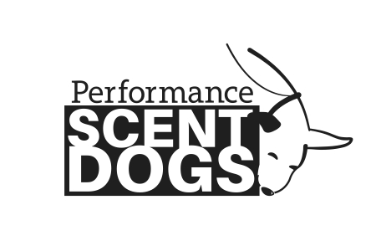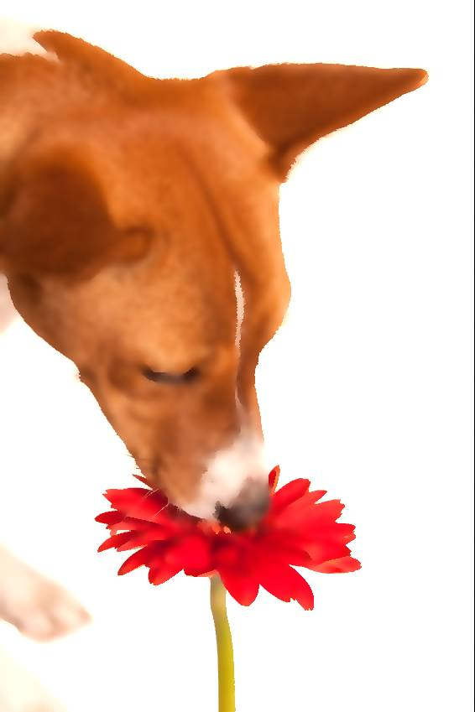

Hosted by
The Puppy Nanny
Trial Location:
Liquid Systems
998 N. Maple St.
Simpsonville, SC 29681

Doors open: 8am; Judges briefing: 8:30am; First dog on the line: 9am
Trial will take place indoors and outdoors.

Match Classes Offered:
Novice Buildings, Exteriors, Speed, and Distance
Advanced Containers
Levels Offered:
TOT Fun Test, All 3 odors

Class Entry Fees: $15 each - TOT $10 each

Trial Judge: Sandy Farrey

Entry open date: March 19, 2018
Entry close date: April 13, 2018 or when classes fill
Entries are limited and accepted on a first received basis until classes fill.
Day of Show entries accepted if runs are still available

Performance Scent Dogs is a national scent work non-profit organization
dedicated to growing the sport of scent detection.

Permission has been granted by Performance Scent Dogs, Inc. for the holding of this Scent Work Event under PSD Rules and Regulations.

The PSD Rulebook can be found at www.performancescentdogs.com
Please review it before entering and trialing.

Fun Facts about PSD
*Pick and choose what classes are right for your dog*
*Videotaping allowed*Earn legs toward titles*Competitor feedback encouraged *Watch and root for other competitors*Turn any search at any time into training by asking the judge the location of the hide*Enter more than one dog*
*Spend time with your dog in a welcoming atmosphere*

»Spread the word about what an amazing activity scent work is for all kinds of dogs«

Come and have FUN with your dog!

Who can compete in a trial? Any and all dogs that are 10 months or older, on the day of the trial or the Target Odor Test (TOT), are eligible to compete. All Dogs must have their current Rabies Vaccination and other vaccinations recommended by your veterinarian.

Do I Need to Register with PSD? PSD registers dogs not people. A $30 registration fee is good for the lifetime of the dog and can be done instantly on-line. A competitor is not required to register for PSD in order to compete in a match.

What if I don’t pass the TOT? You can still play!! Dogs must pass a Target Odor Test (TOT) in order to compete in the Standard Division, however if you do not pass you are still allowed to enter the trial as FEO (For Exhibition Only) for the day.

My dog has a Nose Work title from a different organization, do I have to pass a TOT? If you already have passed an odor test in another scent work organization, you do not have to take the TOT. Dogs with a NW3, SDDA Excellent or UKC Level 5 title may skip the Novice level and start PSD at the Advanced level. Please send a copy of your test results to info@performancescentdogs.com in order to register.

Can I watch other competitors? Yes you can watch, either after you run or you can watch a different level compete.

Can my friend videotape my searches? Yes! And you may post them anywhere you like.

Awards: Placement ribbons will be awarded for 1st-3rd place

Fees: Classes: $15 each TOT: $10

To register your dogs: Please visit www.performancescentdogs.com mail your $30.00 registration fee (per dog) payable to Performance Scent Dogs. Please include your information (Name, Address, Email, Phone) as well as your dog’s information (Name, Breed, date of dog birth). Performance Scent Dogs, Inc. PO Box 401026 Cambridge, MA 02140
A competitor is not required to register for PSD in order to compete in a match.

Complete this registration form and mail it to the Trial Secretary along with your payment made payable to The Puppy Nanny. Entries are on a first-received basis and must be received by April 13, 2018.

Trial Secretary

Sue Conklin
111 Bell Dr.
Simpsonville, SC 29681
puppynanny@bellsouth.net
Please make checks payable to The Puppy Nanny.
***Do not make checks payable to PSD***

Collars: Any collar is allowed on the grounds except electronic and scent spraying collars. Only a flat, or martingale collar or leashes attached to a dead ring or harness are permitted to be used during a search. No tags on collars while searching. All dogs must be leashed at all times, except during an off-leash search.

Crating: Dogs will be crated in your car. No indoor crating is available.

Parking: There is ample parking, some shaded, but plan on keeping your car cooled if necessary.

Spectators: Spectators are invited to come and watch a PSD trial or a match Some Interior areas may be too small for spectators.

Volunteers will help our Trial/Match run smoothly. We need Timers, Gate Stewards, Score Runners, and Others. No Experience Required! No need to give up a day-volunteers get to run first in their class. Thanks in advance for your help. Volunteer info will be on the Puppy Nanny website.

Donations: This Match is supporting a local rescue. Please support Lucky Pup Rescue by bringing in any of the following donations: The rescue is currently in most need of Collars, Harnesses, Leashes, Puppy pads, Canned or Dry Dog/Puppy Food, Kongs, Disinfectant Cleanser, Hand Soap, Paper Towels and Monetary Donations.

Food: POT LUCK! Please plan on bringing something to share. We will need a wide variety of foods, so be creative! Please contact Hospitality Chair Renee Renaut and let her know what you would like to bring. renee.renaut@yahoo.com

Facility, Bathrooms and Water: Climate controlled, water and toilets available on site.

Accessibility: No more than 1 step in or out of any search area.

Dogs In Need of Space The site has plenty of parking, but cars may be close together. There are places to walk dogs at a distance of 10 feet or more. There is a single entrance and exit for interior searches that could be congested. Volunteers will be onsite to help escort participants to and from the search area. Red bandanas are encouraged - please give all dogs space.

Handler running multiple dogs: At this match, a handler may only run one dog in each class.
A second or third dog can run FEO.

24h Emergency Vet;
1

Animal Emergency Clinic
393 Woods Lake Rd, Greenville · (864) 232-1878

Dog Friendly Hotels;
We have made no arrangements with any hotel. Please contact the hotel directly to confirm their policy.

Days Inn Simpsonville (864) 963-7701
45 Ray East Talley Court, Simpsonville, SC 29680

Quality Inn Simpsonville-Greenville (864) 963-2777
3755 Grandview Drive, Simpsonville, SC 29680,

Motel 6 Greenville – Simpsonville (864) 962-8484
3706 Grandview Drive, Simpsonville, SC 29680,

Please complete the following 2 pages and mail with check for entry fees (made out to The Puppy Nanny) to Sue Conklin 111 Bell Dr, Simpsonville SC 29681

Performance Scent Dogs Sanctioned Match
Hosted by The Puppy Nanny – April 21, 2018
Owner
Handler
Email
Phone
Emergency Contact
Dogs Call Name
Breed

 |  | Target Odor Fun Test (TOFT)
Odor |  |  | Birch ($10) |  | Anise ($10) |  | Clove ($10)
Entry
 |  |  |  |  |  | Total $ TOT

Match Classes Offered (choose a level and a division)
 |  | Division |  |  | Level | Level
Entry | FEO | Standard |  | Metallic | Novice | Advanced
 |  |  |  | NA | ($15 ea)
Buildings |  |  |  | NA | Novice | NA
Distance |  |  |  | NA | Novice | NA
Speed |  |  |  | NA | Novice | NA
Exteriors |  |  |  | NA | Novice | NA
Containers |  |  |  | NA | NA | Advanced
 |  | Total # Runs: ____ x $15 =
 |  |  |  |  |  | Total Entry Fees:
Division Information:
FEO = For Exhibition Only
Standard = Competing for your title
Metallic = Already received title and competing for Metallic Awards

Entry must be received by April 13, 2018 – One entry per dog, 2nd dog runs FEO
Checks: made out to The Puppy Nanny
Please mail to: Trial Secretary – Sue Conklin, 111 Bell Dr, Simpsonville, SC 29681

Release of Liability

Release of Liability Name: _____________________________________
Dog's Name: _______________________________________________

I certify that I am the actual owner of the dog, or that I am the duly authorized agent of the actual owner whose name I have entered above. In consideration of entering this Performance Scent Dogs sanctioned trial, I (we) agree to abide by the rules and regulations of Performance Scent Dogs, Inc. in effect at the time of this event, and by any additional rules and regulations appearing in the rulebook dated March 2016 for this event, and further agree to be bound by this liability waiver for all dogs in my care at this event, entered or not. I (we) certify and represent that the dog entered is not a hazard (dog or human aggressive) to persons or other dogs. This entry is submitted for acceptance on the foregoing representation and Agreement. I (we) agree to conduct myself (ourselves) in accordance with all Performance Scent Dogs, Inc. Rules and Regulations and to abide by any decisions made in accord with them. I (we) agree that the club holding this event has the right to refuse this entry for cause, which the club shall deem sufficient. I (we) agree to hold Performance Scent Dogs, Inc., The Puppy Nanny LLC and Liquid Systems, their members, directors, governors, officers, agents, or event secretary and the owner and/or lessor of the premises and any provider of services that are necessary to hold this event and any employees or volunteers of the afore-mentioned parties harmless from any claim for loss or injury which may be alleged to have been caused directly or indirectly to any person or thing by the act of this dog while in or about the event premises or grounds or near any entrance thereto, and I (we) personally assume all responsibility and liability for any such claim; and I (we) further agree to hold the a fore mentioned parties harmless from any claim for loss, injury or damage to this dog. Additionally, I (we) hereby assume the sole responsibility for and agree to indemnify, defend and save the aforementioned parties harmless from any and all loss and expense (including legal fees) by reason of the liability imposed by law upon any of the aforementioned parties for damage because of bodily injuries, including death at any time resulting therefrom, sustained by any person or persons, including myself (ourselves), or on account of damage to property, arising out of or in consequence of my (our) participation in this event, however such, injuries, death or property damage may be caused, and whether or not the same may have been caused or may be alleged to have been caused by the negligence of the aforementioned parties or any of their employees, agents, or any other persons.

Waiver of Rights to Privacy, Publicity & Personality
In consideration of this entry, I hereby grant to Performance Scent Dogs, Inc. and The Puppy Nanny LLC all rights and permissions to use or appropriate my dog and my name, biography, likeness, photograph or other indicia of identity for broadcast, telecast, transmission or distribution in any format or media known now or in the future.

Signature: ___________

Date:

