Performance Scent Dogs Trial in Willow Grove, PA

Saturday March 7, 2020

Premium List

Shamrock Sniffer
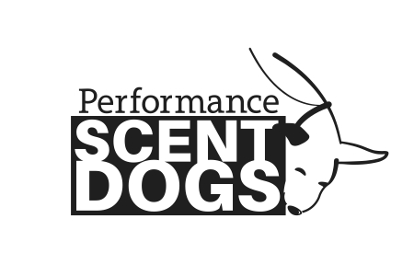
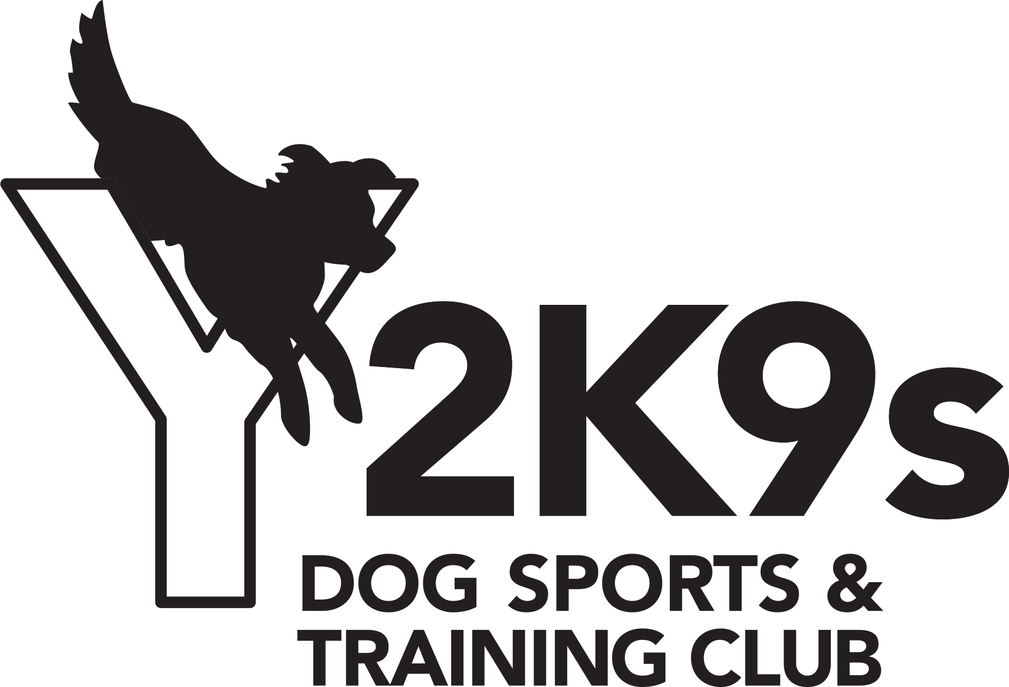

Hosted by:
Y2K9s Dog Sports & Training Club

Trial Location:
Y2K9s Dog Sports & Training Club
601 Davisville Road, Suite 150
Willow Grove, PA 19090

Doors open: 8:00am; Judges briefing: 8:30am; First dog on the line: 8:45am
Trial will take place indoors.

Target Odor Test:  Birch, Anise &  Clove | Trial Classes Offered:  Buildings, Speed, Distance, & 2 Containers | Levels Offered:  Novice, Advanced  Excellent | Divisions Offered:  FEO, Standard, & Metallic
TOT Fees: $15 each
Class Entry Fees: $20 each
On-line entry and electronic payments only

Trial Judges:

Sarah Woodriff & Bernetta Dougert

Trial Chair Trial Secretary

Alexa Karaoulis Roberta Earle

akaraoulis@gmail.com TrackingLabs@aol.com

Entry open date: January 10, 2020
Entry close date: February 21, 2020 or when classes fill
Entries are limited and accepted on a first received basis until classes fill.

*Due to space limitations and a single entrance, please no Dogs in Need of Space (aka reactive dogs).
For more information, please refer to that section of this document or contact the Trial Secretary.

Performance Scent Dogs

Performance Scent Dogs is a national scent work non-profit organization dedicated to growing the sport of scent detection.

Performance Scent Dogs, Inc. has granted permission for the holding of this Scent Work Event under PSD Rules and Regulations.

The PSD Rulebook can be found at www.performancescentdogs.com
Please review it before entering and trialing.

Fun Facts about PSD
*Pick and choose what classes are right for your dog
*Videotaping allowed
*Earn legs toward titles
*Competitor feedback encouraged
*Watch and root for other competitors
*Turn any search at any time into training by asking the judge the location of the hide
*Enter more than one dog
*Spend time with your dog in a welcoming atmosphere

»Spread the word about what an amazing activity scent work is for all kinds of dogs«

Come and have FUN with your dog!

Trial Information

Registration for the Trial:

Register online at www.performancescentdogs.com. Entries are on a first received basis and must be received by February 21, 2020. Once entries fill, additional entries will be placed on the waitlist. You will be notified by email if a spot opens up.
Cancellations/Move-Ups/Refunds:
- Cancellations completed before the cancellation date, February 21, 2020, will receive a full refund.
- Cancellations requested after the cancellation date, February 21, 2020, will not receive a refund, including no-shows at the trial.
- If you earn a title in the entered class before this trial, please complete and submit the online Move Up Form no later than March 2, 2020.
Tentative Run Order:
- TOT – Novice containers 1 at the same time
- Νοϖιχε – χονταινερσ 2 το διστανχε φολλοωεδ βψ σπεεδ το βυιλδινγ
- Αδϖανχεδ – χονταινερσ 1 φολλοωεδ βψ χονταινερσ 2 το διστανχε φολλοωεδ βψ σπεεδ το βυιλδινγ
- Εξχελλεντ – χονταινερσ 1 φολλοωεδ βψ χονταινερσ 2 το διστανχε φολλοωεδ βψ σπεεδ το βυιλδινγ

General Information

Who can compete in a trial? Any and all dogs that are 10 months or older, on the day of the trial or the Target Odor Test (TOT), are eligible to compete. All Dogs must have their current Rabies Vaccination and other vaccinations recommended by your veterinarian.

Do I Need to Register with PSD? PSD registers dogs not people. A $30 registration fee is good for the lifetime of the dog and can be done instantly on-line.

To register your dogs: Please visit www.performancescentdogs.com or mail your $30.00 registration fee (per dog) payable to Performance Scent Dogs. Please include your information (Name, Address, Email, Phone) as well as your dog’s information (Name, Breed, date of dog birth). Performance Scent Dogs, Inc. PO Box 401026 Cambridge, MA 02140

What if I don’t pass the TOT? You can still play!! Dogs must pass a Target Odor Test (TOT) in order to compete in the Standard Division, however if you do not pass you are still allowed to enter the trial as FEO (For Exhibition Only) for the day.

My dog has a Nose Work title from a different organization; do I have to pass a TOT? If you already have passed an odor test in another scent work organization, you do not have to take the TOT. Dogs with an NW3, SDDA Excellent, or UKC Level 5 title may skip the Novice level and start PSD at the Advanced level. Please send a copy of your test results to info@performancescentdogs.com in order to register.

Can I watch other competitors? Yes you can watch, either after you run or you can watch a different level compete.

Can my friend videotape my searches? Yes! And you may post them anywhere you like.

Awards: Rosette placement ribbons will be awarded for 1st-3rd place in the Standard and Metallics division. Ribbons will be awarded for Q’s in all classes, including TOT’s. Iron Nose Award for Teams Qualifying in all classes possible each day. Judges Choice Award for team or teams exemplifying Spirit of PSD. Fastest Search.

Collars: Any collar is allowed on the grounds except scent spraying collars. Only a flat, or martingale collar or leashes attached to a dead ring or harness are permitted to be used during a search. No tags on collars while searching. All dogs must be leashed at all times, except during an off-leash search.

Crating: Indoor crating is not available at this location. Please make arrangements for your dog to comfortably wait in your car. You may not crate your dog outside of the car.

Parking: Large paved parking area with no shade.

Spectators: Invited to come and watch a PSD trial or a match.

Volunteers: Help our Trial run smoothly. We need Timers, Gate Stewards, Score Runners, and Others. No Experience Required! No need to give up a day as volunteers run first in their class. Lunch will be provided to those that volunteer. Thanks in advance for your help.
To volunteer contact Vicky Nelson at mach2dvm@hotmail.com.

Food: Lunch will be provided to volunteers. For everyone else, the Willow Grove Mall, multiple fast food options, and a Wawa are less than a five-minute drive.

Smoking: Not permitted in the building.

Facility: Climate controlled. Water and bathrooms are available on site. There is no smoking in the building.

Weather/Shade: Competitors will be outdoors or in their vehicle most of the day. There is no shade in the parking area. Be prepared for changing weather conditions (heat, rain, snow, wind). You may run your vehicle for the comfort of you and your dog. Please be considerate of the folks parked near you who may not want to breathe the exhaust from your vehicle.

Accessibility: No stairs or steps for entry.

RV parking: No parking for RVs.

Bitches in season: Contact the trial secretary, Roberta Earle (TrackingLabs@aol.com).

Handler running multiple dogs: A handler can run multiple dogs in TOTs at any trial/match. At this trial a handler may run one dog in each class. For example, a handler may run one dog in novice containers and a different dog in novice buildings.

Dogs In Need of Space: If your dog is reactive or needs extra space, please do not bring him/her to this location. While there is plenty of parking, there is a single entrance and exit for all search areas and the potty area is located near the entrance. You may be closer to other dogs than is comfortable for your dog. Please do not put your dog in a stressful situation.

24h Emergency Vet:
Veterinary Specialty & Emergency Center
625 Ridge Pike, Building B
Conshohocken, PA 19428
484.567.7999

Dog Friendly Hotel:
We have made no arrangements with any hotel. Please contact the hotel directly to confirm their policy.

Days Inn Horsham/Philadelphia:
245 Easton Road
Horsham, PA 19044
(215) 674-2500

