Performance Scent Dogs Trial – MASK UP!

Sunday August 16, 2020

Premium List
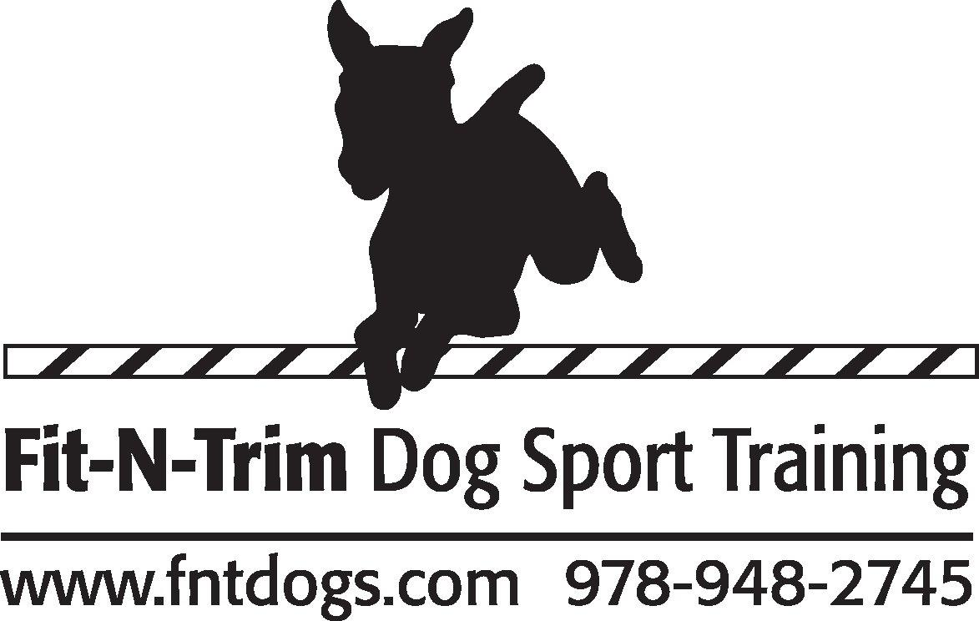
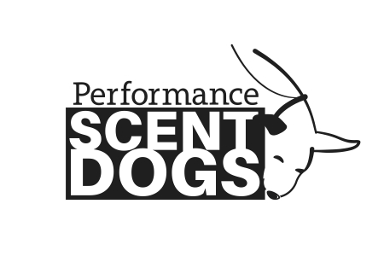

Hosted by
FIT-N-TRIM
Trial Location:
At the Big Arena!
103 Haverhill Street (Rt 133)
Rowley, MA 01969

8:00 am-TOT’s & Novice Exteriors, 8:30 Inside Novice classes, 10:30 Advanced, 12:30 Excellent
(Adv and Excel start times are estimates) Trial will take place indoors & outdoors. Dress appropriately!

Target Odor Test: Birch, Anise and Clove
Trial Classes Offered:
EXTERIORS (2) Speed, Containers (2), Distance
Levels Offered:
Novice, Advanced, Excellent
Divisions Offered:
FEO, Standard and Metallic

TOT and Class Entry Fees: $15 each (TOT), $20 each (Classes)

Trial Judges Extraordinaire: Jen Belanger & John Rumson

Class run Order (Tentative)

Outside: Exteriors, Exteriors, Containers (ALL 3 ON YOUR TURN)

Inside: Containers, Distance, Speed (ALL 3 ON YOUR TURN)

Entry open date: 07/20/20
Entry close date: 8/10/20 or when classes fill.

Entries are limited and accepted on a first received basis until classes fill.
Day of Show entries TBD

Performance Scent Dogs is a national scent work non-profit organization dedicated to growing the sport of scent detection.

Permission has been granted by Performance Scent Dogs, Inc. for the holding of this Scent Work Event under PSD Rules and Regulations.

The PSD Rulebook can be found at www.performancescentdogs.com
Please review it before entering and trialing.

Fun Facts about PSD
*Pick and choose what classes are right for your dog*
*Videotaping allowed*Earn legs toward titles*Competitor feedback encouraged *Watch and root for other competitors*Turn any search at any time into training by asking the judge the location of the hide*Enter more than one dog*
*Spend time with your dog in a welcoming atmosphere*

»Spread the word about what an amazing activity scent work is for all kinds of dogs«

Come and have FUN with your dog!

Who can compete in a trial? Any and all dogs that are 10 months or older, on the day of the trial or the Target Odor Test (TOT), are eligible to compete. All Dogs must have their current Rabies Vaccination and other vaccinations recommended by your veterinarian.

Do I Need to Register with PSD? PSD registers dogs not people. A $30 registration fee is good for the lifetime of the dog a=can be done instantly on-line.

What if I don’t pass the TOT? You can still play!! Dogs must pass a Target Odor Test (TOT) in order to compete in the Standard Division, however if you do not pass you are still allowed to enter the trial as FEO (For Exhibition Only) for the day.

My dog has a Nose Work title from a different organization, do I have to pass a TOT? If you already have passed an odor test in another scent work organization, you do not have to take the TOT. Dogs with a NW3, SDDA Excellent or UKC Level 5 title may skip the Novice level and start PSD at the Advanced level. Please send a copy of your test results to info@performancescentdogs.com in order to register.
Can I watch other competitors? Yes you can watch, either after you run or you can watch a different level compete.

Can my friend videotape my searches? Yes! And you may post them anywhere you like.

Awards: Rosette placement ribbons will be awarded for 1st-3rd place. Ribbons will be awarded for Q’s in all classes, including TOT’s.
Judges Choice Award for the team exemplifying Spirit of PSD.
Iron Nose Trophy’s, Overall Metallic Trophy’s (ex: All of Novice Silver)!
ALL AWARDS MUST BE PICKED UP DAY OF TRIAL!

Fees: TOTs and Classes: $15 each (TOT), $20 each (Classes)

To register your dogs: Please visit www.performancescentdogs.com or mail your $30.00 registration fee (per dog) payable to Performance Scent Dogs. Please include your information (Name, Address, Email, Phone) as well as your dog’s information (Name, Breed, date of dog birth). Performance Scent Dogs, Inc. PO Box 401026 Cambridge, MA 02140

You can register for this trial online at www.performancescentdogs.com or complete this registration form and mail it to the Trial Host along with your payment made payable to
FIT-N-Trim. Entries are on a first-received basis and
must be received by 08/10/20. Please let Ellen know if you mailed it late!

Trial Secretary

Ellen Dana (EllenDana@Gmail.com)

Please make checks payable to FIT-N-TRIM and Mail to:
103 Haverhill Street, Rowley, MA 01969 ***Do not make checks payable to PSD***

Collars Any collar is allowed on the grounds except scent spraying collars. Only a flat, or martingale collar or leashes attached to a dead ring or harness are permitted to be used during a search. No tags on collars while searching. All dogs must be leashed at all times, except during an off-leash search. No Flexi-Leashes allowed.

Crating There will be no crating at this event.

Parking Sufficient parking area. Please watch for cone or signs indicating an area is off limits for parking-it may be a search area.

Spectators due to COVID-19, please limit spectators

Volunteers will help our Trial run smoothly. We need Timers, Gate Stewards, Score Runners, and Others. No Experience Required! No need to give up a day-volunteers get to run first in their class. Thanks in advance for your help. Lunch will be provided to those that volunteer.

Food Lots of places nearby. We will not be offering any food at this trial. Please bring food and water for you and your dog (s).

Facility, Bathrooms and Water Be prepared for all kinds of weather, Bring water for you and your dog(s), Porta-Potty available on site.

Accessibility No stairs or steps for entry.

Dogs In Need of Space The site has plenty of parking and places to walk dogs at a distance of 10 feet or more. Please give ALL DOGS space! Volunteers will be onsite to help escort participants to and from the search area. Please look out for Red bandanas on dogs +/or people who need to be given wide margins.

Handler running multiple dogs A handler can run multiple dogs in TOTs at any trial/match. At this trial, a handler may only run one dog in each class. A second or third dog can run FEO.

24h Emergency Vet
Bulger Veterinary Hospital
247 Ckickering Rd,North Andover,MA
978-682-9905

Dog Friendly Hotel
We have made no arrangements with any hotel. Hotels below are listed as Dog Friendly.

Motel 6 (12 Miles)

65 Newbury Street (rt 1 North)

Danvers MA 01923

978-774-8045

Best Western (11 miles)

50 Dayton Street

Danvers, MA 01923

978-777-1700

Hampton Inn (13 Miles)

106 Bank Road (I-495 exit 49)

Haverhill, MA 01832

978-374-7755

MOST IMPORTANT THING TO REMEMBER – HAVE FUN WITH YOUR DOG!

Performance Scent Dogs Sanctioned Trial
Hosted by FIT-N-Trim AUG 16, 2020
Owner
Handler
Address
City |  |  |  |  | State |  | Zip
Email
Phone
Emergency Contact
Dogs Call Name
Breed |  |  |  |  |  | Sex
PSD Registration #

 |  | Target Odor Tests (TOT)
Odor |  |  | Birch ($15) |  | Anise ($15) |  | Clove ($15)
Entry
 |  |  |  |  |  | Total $ TOT
Trial Classes Offered (choose a level and a division)
 |  | Division |  |  |  | Level
Entry | FEO | Standard |  | Metallic | Novice | Advanced | Excellent
 |  |  |  |  | ($20 ea) | ($20 ea) | ($20 ea)
Exteriors 1
Exteriors 2
Containers 1
Containers 2
Distance
Speed
 |  | Total #TOT’S: ___ x $15 =
 |  |  |  |  |  | Total # Runs: | ___ x $20 =
Checks to: FIT-N-TRIM |  |  |  |  |  | Total Entry Fees:
Division Information:
FEO = For Exhibition Only
Standard = Competing for your title
Metallic = Already received title and competing for Metallic Awards

Entry must be received by 08/10/20 – One entry per dog
Please mail to: Karen Gorman, Fit-N-Trim, 103 Haverhill Street, Rowley, MA 01969
Fit-N-Trim Covid-19 Statement for scent trials

COVID-19 Statement Event Date: AUGUST 16, 2020

I pledge to promote my own safety as well as that of the exhibitors, judges, volunteers, FNT owners, employees, and assistants at Fit-N-Trim Training events. I have read, understand, and agree to follow the rules and procedures listed below.

To the best of my knowledge, I do not have COVID-19
I have not been exposed to COVID-19 within the last 3 weeks
- I have had no symptoms (fever, cough, etc.) for the past 2 weeks
I agree that should these conditions take place; I will contact the trial secretary for 100% refund:

- Should I feel ill before the trial
- Should I find I have been exposed to the virus

I agree:
- To wear a face covering in the building, in the outside trial area and even when running my dog
- To practice social distancing (6’ or more)
- To hand wash/sanitize frequently. I understand if I am not in compliance with these guidelines and refuse to comply, I will be asked to leave and any entry fees forfeited.
- I am entering this trial of my own volition and am responsible for my own health. Karen and John Gorman , Fit-N-Trim Training, any employees or agents, and assistants are in no way liable for any present or future COVID-19 infection incurred by any person in attendance or not in attendance, before, during, or after above stated event.
The COVID-19 virus situation is continually changing, and I understand these guidelines may be changed as needed. I understand that to complete my entry, my signature is REQUIRED, verifying agreement with this document, or my entry will be refunded.

Name: _____________________________________________Date:________________________

Signature:__________________________________________________

IMPORTANT: THIS MUST BE SIGNED AND EMAILED, OR MAILED WITH ENTRY OR BROUGHT TO THE TRIAL AND DELIVERED BEFORE I AM ABLE TO COMPETE.

EXTRA COVID-19 NOTES

1. Regarding Gate Sheets: We will do a "roll call' Type of check in, just call out peoples' names, so ONLY the Gate steward touches that classes board.
The gate steward MUST stay 6 ' away. No exhibitors touching the gate sheets or pens etc

The Trial Secretary will separate dogs in the running order

2. Crating only in your car, NO INDOOR Crating, pop up tents are ok.

3. NO hospitality (our apologies), please bring your own food and drink.

4. Ribbon table will be set up outside, ONE person will be handling the ribbons. No more than 5 people standing in line for the ribbon please use social distancing of 6’ and don’t forget to wear your mask. The ribbon person will wear a mask and have disinfectant. Please pick up your Q ribbons right after your runs.

5. Trial Secretary will email the trial results.

6. LINE UP TO RUN: There will be distance marks for where to stand.

7. MASKS ARE REQUIRED AT ALL TIMES except when at your car. Exhibitors will need to bring enough masks for the duration of the trial and dispose of single use masks properly. If you are unable to wear a mask for a medical reason, please bring a copy of your doctor’s note exempting you from wearing your mask.

8. There will be sanitizer available.

